|  |  |  |  |
| --- | --- | --- | --- |
|  | **Course Name: Advanced Web Technology** | **EXPERIMENT NO. 1** | |
| **Course Code: 20CP314P**  **Faculty: Komal Singh** | **Branch: CSE** | **Semester: VI** |
| **(To be filled by Student)**  **Submitted by: Puja Mavadhiya**  **Roll no: 21BCP446D** | | | |

Objective: Building a Simple Web Server in Node.js

Experiment: Implement the NodeJS Programs.

Q.1 Write Node JS programs for following modules:

1. http

const http = require("http");

const url = require("url");

http.createServer(

    function (req, res){

        res.writeHead(200, {

            "Content-Type": "text/plain"

        });

        const parsedUrl = url.parse(req.url, true);

        const {pathname, query} = parsedUrl;

        if(pathname === "/"){

            res.end("Welcome to Home Page " + query.name);

        } else if

        (pathname === "/about"){

            res.end("Welcome to about page "+ query.name);

        } else{

            res.end("Welcome "+query.name);

        }

    }).listen(8000, ()=>console.log("Server started at 8000"));

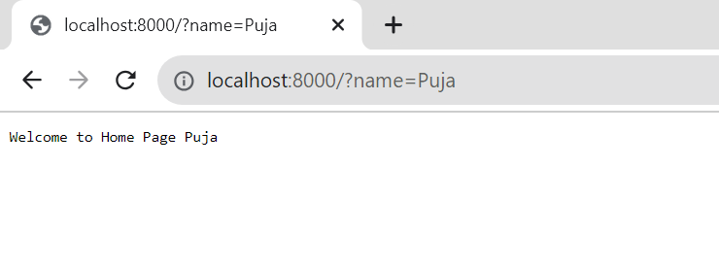

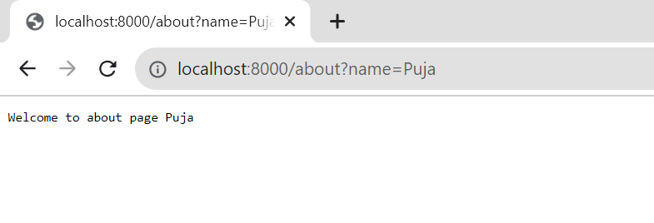

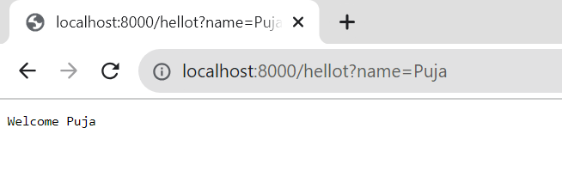

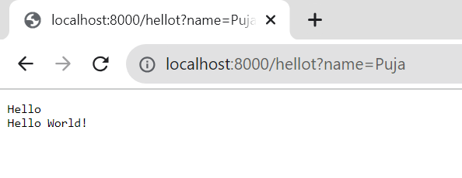

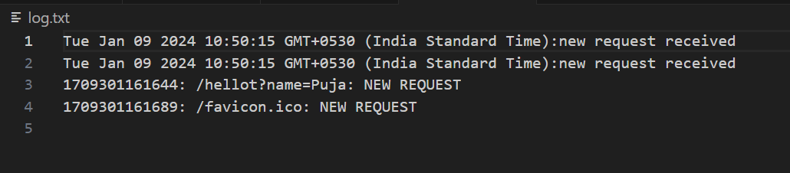

1. filesystem

const http = require("http")

const fs = require("fs")

const server = http.createServer((req, res) => {

    console.log(req.headers)

    res.write("This is the response from the server")

    const d = new Date()

    const log = `${d}:new request received\n`;

fs.appendFile('log.txt',log,(err,data)=>{});

switch(req.url){

    case "/":

        res.end("\n Home Page");

        break;

    default :

        res.end("\n default page");

        break;

}

res.end();

})

server.listen((3001), () => {

    console.log("Server is Running");

})



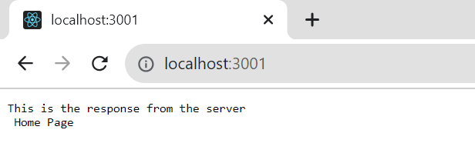

1. url

const url = require("url");

const http = require("http");

http.createServer(function (req,res){

const parsedUrl =

url.parse("https://www.w3schools.com/nodejs/nodejs_events.asp", true);

const data = {

'Protocol': parsedUrl.protocol,

'Host': parsedUrl.host,

'Path': parsedUrl.pathname,

'Query': parsedUrl.query,

'Fragment': parsedUrl.hash

}

const responseData = JSON.stringify(data);

res.setHeader('Content-Type', 'application/json');

res.end(responseData);

}).listen(8000, () => console.log("Server started at port: 8000"));

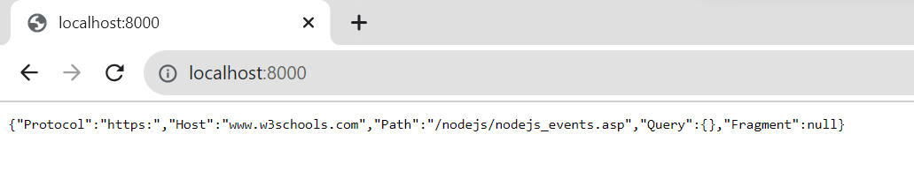

1. event

// Importing event module

const event = require("events");

// Create an instance of the event emitter class

const myEmitter = new event();

const myEventHandler = () =>{

console.log("I am Listening");

}

myEmitter.on('customEventWithData', (data) => {

console.log('Custom event with data:', data);

});

// Emit the custom event with data

myEmitter.emit('customEventWithData', "Hello World");

myEmitter.on("myCustomEvent", myEventHandler);

myEmitter.emit("myCustomEvent");

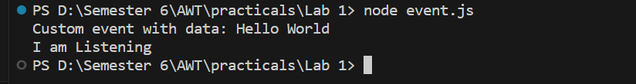

Note: Please include snapshots of all commands, terminal sessions, localhost outputs, and log files in your documentation."